

**Tobor Inc.**

App Automation: Register, Deliver and Report

Detailed Process Description

Version 1.10

Revision History

|  |  |  |  |
| --- | --- | --- | --- |
| Date Issued | Version | Description | Author |
| *16.06.2020* | *1.0* | *Initialize* | *James Harper* |
| *17.06.2020* | *1.01* | *Updates* | *James Harper* |
| *18.06.2020*  *21.06.2020*  *23.06.2020* | *1.02*  *1.03*  *1.10* | *Updates*  *Updates*  *Finished alpha file. Ready to be sent for basic review with some properties needing finished* | *James Harper*  *James Harper*  *James Harper* |

Contributors

The content of this document has been authored with the combined input of the following group of key individuals.

|  |  |  |
| --- | --- | --- |
| Name | Role | Area |
| *James Harper* | *RPA Developer* | *Consulting* |

Business Sign-off

The following table contains the people required to sign-off and/or review this document and those that require the document for information only.

|  |  |  |
| --- | --- | --- |
| Name | Department | Responsibility |
| *David Bradbury* | *Management Director* | *Sign Off* |
| *Roberto Fernandez* | *Backend Application Manager* | *Review* |
| *Chris Lucas* | *Consultant Project Liaison* | *Information* |

Document Classification

|  |  |
| --- | --- |
| Classification | *Person Confidential* |
| Definition | *Program is to be kept within the domain of Roberto Fernandez* |
| Context | *Customer details are to be kept within the program itself and not taken outside of the scope where possible. Knowledge of the coding itself is to be kept with the Application manager* |
|  |  |

Contents

1 Introduction 4

2 Manual Process 4

2.1 Overview 4

2.2 Detailed Process Flow 4

3 Automation Proposal 4

3.1 Overview 4

3.2 Automated Process Flow 4

3.3 Target Systems & User Requirements 4

3.4 Impacted Business Areas 5

3.5 Workload 5

3.6 Operational Constraints 5

3.7 Delivery 5

3.8 Contact List 5

4 Automation Details 6

4.1 Automation Walkthrough 6

4.1.1 *First robot action* 6

4.1.2 *second robot action* 6

4.1.3 *third robot action etc.* 6

4.2 Reporting 6

4.2.1 Business Exceptions 6

4.2.2 System Exceptions 6

4.2.3 Performance 7

4.2.4 Triggers 8

# 1 Introduction

*Tobor Inc. has requested consultation with their app automation. This process involves taking in registering details from a customer to create a presence on their software.*

*This then goes onto expand with taking in data from a selection of websites that the user selects via a pre-defined list of hobbies, e.g. sports and hobbies. Then the automation goes onto tidy up the data and send it to the user.*

*Lastly, the user options they requested are tallied down and noted as means of data collection for Tobor Inc. to help with further development.*

# 2 Manual Process

## 2.1 Overview

* *User sends their registration details to the company email. Details being the user’s first name, last name, phone number, address, email address, the content they request and the frequency it gets delivered.*
* *Details are then stored by the company, usually locally, with the option of changing/removing them.*
* *Content is taken from three different website options (Sport, Tech, Hobbies) daily. Content being described as a brief description of what’s going on.*
* *A report is taken before the content is sent off, noting who will receive that aggregated data and what the day is.*
* *These reports are then compiled together into a larger report of what was sent out on that day. This is stored locally on a company computer.*

## 2.2 Detailed Process Flow

Registration: Content Delivery:

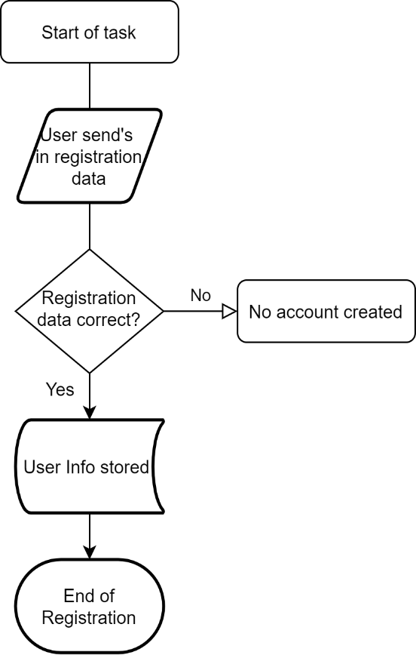 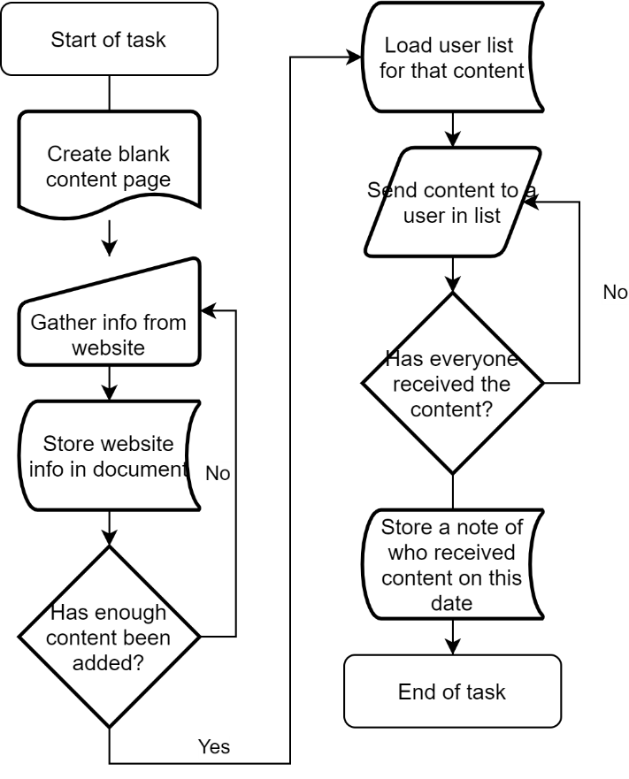

Report Collation:

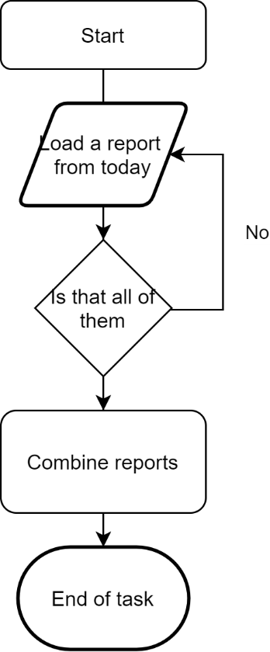

# 3 Automation Proposal

## 3.1 Overview

*The automation proposed would take care of the registering, content aggregation, report filing and content delivery. There is to be an overarching automation aspect that happens at half eleven in the morning triggering all the processes contained. If any submissions are to be made after this deadline, they will need to be held until the next day.*

*Registering would occur via the user sending their details, as described in the manual process, to the company email. In this case we’re using a new outlook e-mail to simulate that as accessing a company email isn’t possible. The Automation involved will then log these details down and send them to the UIPath Orchestrator as an individual object with its own unique identifier. If any of these users send an incomplete dataset, or there are other problems an email will be sent back to the user stating as such, while also logging a fatal error with UIPath. A follow up e-mail can then be sent at the user’s discretion if they want their detail altered or removed with sending a subject of ‘CHANGE’ or ‘DELETE’.*

*The second automation proposes that select websites be used for the content aggregation. For this, each hobby will have a list of websites it needs to access for it’s data set. Every day the automation will go to the websites given and collect snippets of data, a title and first paragraph for example, depending on the website. The automation will then take the snippets and format it to look more presentable to the user, then send the final product in an email. Once sent a local report will be generated to say who this was sent to, and on what date. This will then be repeated for every hobby class for that day.*

*Lastly, the content reports are collected for that day, collated together and sent to the company email, or the QA email in this case. These are marked with how many people ordered that topic for that day.*

## 3.2 Automated Process Flow

*Main Process:*

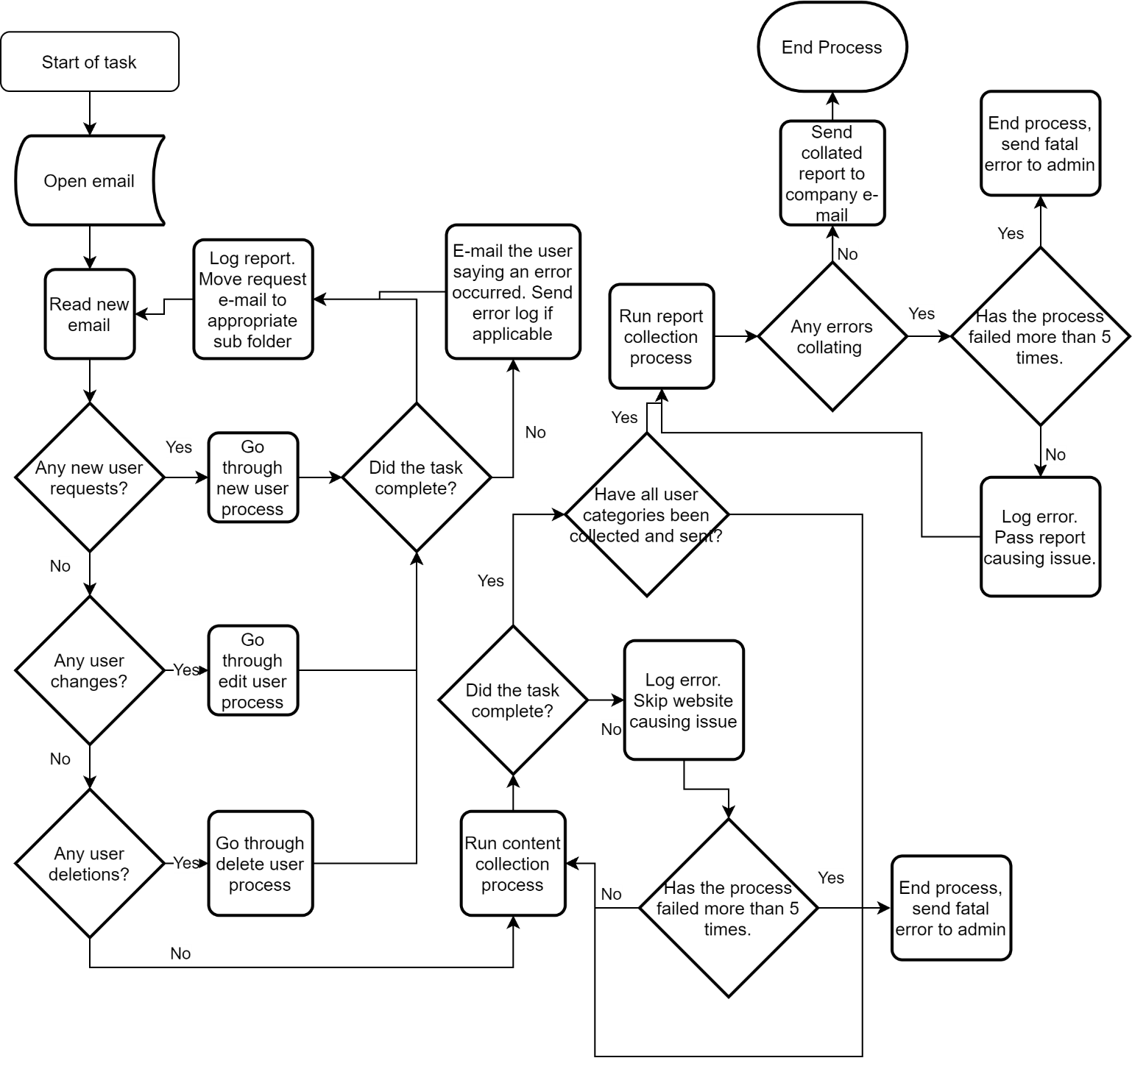

## 3.3 Target Systems & User Requirements

| Name | Description | User Permissions/Access |
| --- | --- | --- |
| *MS Outlook* | *Email inbox simulating the company box* | *Company Inbox required: TroborUser@Outlook.co.uk* |
| *Gmail* | *Email inbox for the user* | *User Inbox required: waddupitsthatrobot@gmail.com* |

## 3.4 Impacted Business Areas

* *Sales*
* *IT*
* *Management*
* *Marketing*

## 3.5 Workload

|  |  |
| --- | --- |
| *Avg no. of Login Requests per week* | *50* |
| *How many people do this process per day?* | *1* |

***Automating the steps below will realise an average time saving of 530 minutes (9.18 hrs) per day for the total process:***

* *New registrations often took a max of 15 minutes per user, with changes taking around the same time. Estimate is based off 10 new users per day.*
* *Aggregation of the content can take a max of 2 hours.*
* *To send this all off is then another 10 minutes.*
* *Reporting was only done when time allowed, with no estimate of how long it taken. However, manually collating the reports should only take around 10 minutes, with an extra 5 per report. With an established base of 50 users a day this would go to 250 minutes.*

## 3.6 Operational Constraints

* *Website maintenance*
* *Email system maintenance*
* *Coding errors*

## 3.7 Delivery

*This is to be delivered on the twenty sixth of June*

## 3.8 Contact List

*David Bradbury – Managing Director*

*Roberto Fernandez – Backend Application Manager and Project PM*

*Chris Lucas – Consultant Liaison*

# 4 Automation Details

## 4.1 Automation Walkthrough

### 4.1.1 *First robot action*

### 4.1.2 *second robot action*

### 4.1.3 *third robot action etc.*

## 4.2 Reporting

### 4.2.1 Business Exceptions

|  |  |
| --- | --- |
| Exception | Solution |
|  |  |
|  |  |
|  |  |
|  |  |
|  |  |
|  |  |

### 4.2.2 System Exceptions

|  |  |
| --- | --- |
| Exception | Solution |
|  |  |

A performance report will be emailed to *Tobor Inc.*  each time the process runs (showing worked cases, exceptions and a cumulative processing log)

### 4.2.3 Performance

Once the processes have successfully completed a performance report and processing log will be emailed to *Roberto Fernandez* as an excel file.

**Performance Report**

This will contain all exceptions (business and system) and successes for the automated Process, based on the last automation execution completion (i.e. based on the last time the process ran)

**Processing Log**

This will show cumulative successes from the automated Process:

**CredBest**

**CredBest**

### 4.2.4 Triggers

*The robot will be triggered at half eleven every morning. Then, depending on user preference, the aggregation and delivery method will fire every day or only every weekend.*